List of Tables

Table 1: Effects of sentinel presence and generalized environment on the proportion of time allocated to each behaviour 10

Table 2: Results of the linear mixed models fit to the mean bout duration 12

Table 3: Result of the linear mixed model fit to forager peck rate 19

Table 4: Results of generalized linear mixed model fit to the number of transitions performed by foragers 22

List of Figures

Figure 1: Map of observations from Crowkemon Go and sampling locations 3

Figure 2: Proportion of time allocated to each behaviour by foragers in commercial and green areas 7

Figure 3: Mean bout duration of foragers in commercial and green areas 9

Figure 4: Mean foraging bout duration of crows in small and large groups 12

Figure 5: Foraging bout duration decreasing with increasing disturbance frequency 13

Figure 6: Mean peck rate of foragers in commercial and green areas 15

Figure 7: Peck rate increasing with increasing disturbance frequency 17

Figure 8: Number of transitions performed by foragers in commercial and green areas 18

Figure 9: Transitions from foraging to alert behaviour increases as disturbance frequency increases 20

Methods

Site Selection

We launched a community science initiative in the greater St. Catharines and Niagara region called Crowkemon Go (www.crowkemon.weebly.com) in spring 2022. Community members were invited to report the location of crows to locate areas with a high likelihood of finding crows. In total, the community recorded 221 crow sightings using Crowkemon Go between January and May 2022. From April-May 2022, we visited potential observation sites and baited them with whole peanuts to attract crows and reinforce an association with food at these locations. We limited data collection to the summer months (June-September 2022) when nestlings are fledging, and groups are less tightly bound by the territory immediately surrounding the nest [1]. One site was selected for recurrent sampling (Fairview Park, 43°10'57.4"N 79°14'44.9"W; Figure 1). We also visited areas with many crow sightings for opportunistic sampling, as the presence of crows was not guaranteed at other potential recurrent sampling locations (Figure 1).

Field observation

Data collection was performed during the 2-3 hours following sunrise (approx. 6-9AM). No sampling was performed when it was raining or during adverse weather (e.g., thunderstorm or heatwave). Upon arriving at the recurrent sampling location, a Nikon D5300 camera with a 70-300mm Nikkor lens was set up on a tripod at a minimum of 15m away from a concrete pad (predetermined bait location). If crows were already foraging in the area, we would begin recording immediately and not bait the site. If not, an observer approached and visibly dropped 30g of Cheez-Its, then returned to the camera. If crows were on-site, recording would start immediately, whereas if the crows were absent, a crow-caller would be used for 20 minutes (5s. call per min, 5 mins on, 5 mins off for 20 minutes or until crows appear) to attract them. We began recording when crows arrived and recorded up to a maximum of 20 minutes. The recording was stopped if the crows vacated the area for longer than 5 minutes and we remained in the area for 10 minutes post-departure in case the crows returned. If the crows returned within 5 minutes, we would continue the trial. For opportunistic sampling, we looked for crows using Crowkemon Go as a guide. If we found crows that were already foraging, we would set up in the same manner as for recurrent sampling and did not bait the site. Conversely, if the crows were not already foraging, we would bait the site as we did for recurrent sampling.

The presence of a sentinel, whether heard or seen, was announced verbally by the observer during the recording, and group size and disturbances (e.g., pedestrians, pets, vehicles) were also verbally noted. For each location, we classified the type of environment using St. Catharines municipal zoning maps. The ‘generalized environment’, a factor used for all subsequent analyses, was categorized by labeling all types of green spaces as “green”, and all types of commercial area as “commercial” (Table S1). Disturbance frequency was calculated by dividing the number of disturbances by the duration of the recording. We identified disturbances as anything passing within 5m of the crows’ foraging area, including vehicles, pedestrians, domestic and wild animals. Group size was binned into two categories: small ($≤$ 4) and large ($>$ 4).

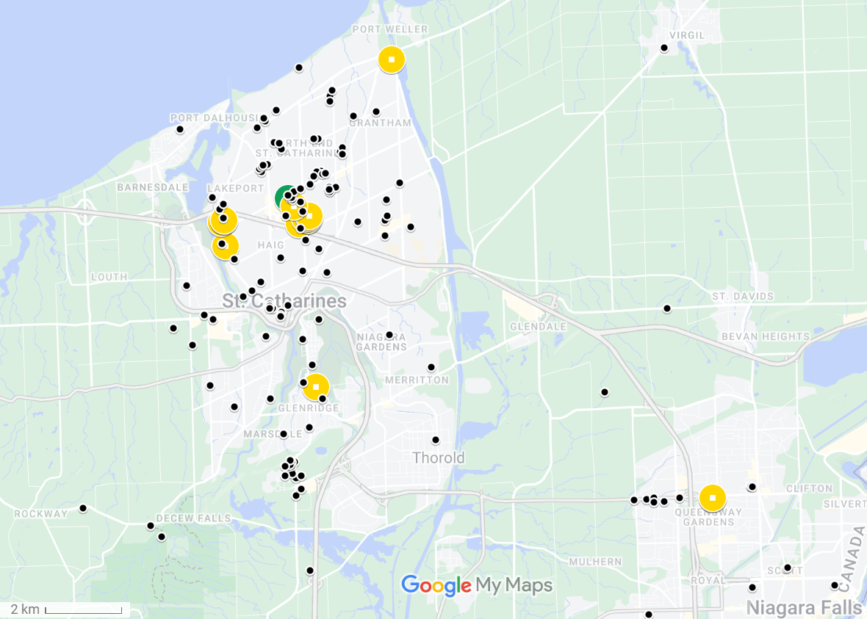

Figure 1: Map of observations from Crowkemon Go and sampling locations. The black dots represent observations collected from Crowkemon Go, and the circular icons are sampling locations. The single recurrent site used is in green. Opportunistic sampling sites are in yellow. Focal area was limited to the St. Catharines & Niagara region.

Video Analysis

For video analyses, we used the Behavioral Observation Research Interactive Software (BORIS v.8.9.4) [2]. We classified behaviours as either “foraging” or “alert”, with “alert” being the behaviour of most vigilance, and “foraging” the behaviour of least vigilance due to the inability of an individual to effectively scan their surroundings while pecking at or looking for food on the ground. The behaviours were defined by the position of the focal individual’s head and body posture (Table S2). We recorded the duration of bouts of each behaviour for every observed individual and bouts of less than 0.01s. were removed. Movement behaviour was recorded, but since not all bouts of movement were recorded in their entirety, “moving” behaviour was excluded from these analyses. We then calculated the proportion of time spent performing each behaviour. An individual could have two observations if it foraged or was alert and sentinel presence changed, as bouts were recorded separately for if a sentinel was present or not.

In addition to these behaviours, we also recorded the number of pecks (handling food with their beaks for the purpose of eating it) to quantify foraging effort. The peck rate (per min) was calculated for every individual by dividing the total number of pecks at food performed by the total duration of “foraging” behaviour. The peck rate of individuals that spent no time foraging could not be calculated and were therefore excluded from peck rate analysis.

Statistical Analysis

All statistical analyses were performed in the R environment (v.4.2.2; R Core Team 2022) [3]. We first ran separate chi-squared tests to determine if the generalized environment, the group size, or the disturbance frequency affected the likelihood of a sentinel being present in our videos. To determine the effects of generalized environment and sentinel presence on the proportion of time foragers allocated to each behaviour (alert or foraging), we used the “lm” function in the R Stats package [3] to fit a linear model using behaviour type, sentinel presence, and generalized environment as predictors. Bouts of “moving” were excluded from this and subsequent analyses.

To determine the effects of generalized environment and the presence of a sentinel on the duration of bouts of all behaviours, we used the function “rlmer” from the “robustlmm” package [4] to fit a robust linear mixed model to the log-transformed duration of bouts with behaviour type, sentinel presence, generalized environment, group size, and bait presence as fixed factors, the disturbance frequency (number of disturbances per min.) as a fixed effect and the individual ID as a random effect. We then fitted post-hoc robust linear mixed models on each behaviour to determine the effects of sentinel presence and generalized environment on each behaviour. The duration of behavioural bouts was log-transformed to normalize the distribution.

To determine the effects of sentinel presence and generalized environment on foraging rate, we used the function “rlmer” from the “robustlmm” package [4] to fit a robust linear mixed model to the peck rate of foragers using sentinel presence, generalized environment, group size, and bait presence as fixed factors, the disturbance frequency (per min) as a fixed effect, and the individual ID as a random effect.

Finally, we counted the number of transitions from each behaviour to determine the effects of sentinel presence and generalized environment on the frequency of each transition type. Using the “glmer” function from the “lme4” package [5], we fitted a generalized linear mixed model using a Poisson distribution to the number of occurrences of each transition. Sentinel presence, generalized environment, and bait presence were fixed factors, the disturbance frequency (per min) was used as a fixed effect, and the total number of transitions performed by the individual was used as a random effect in the model.

Post hoc estimated marginal means tests were performed as appropriate using the “emmeans” function from the “emmeans” package [6]. P-values were corrected using the “fdr” method, and the results were averaged over the unused categorical factors.

Results

Sentinel presence

In summer 2022, we recorded 25 videos of crows foraging and made 13 observations in commercial and 20 observations in green areas. Since the presence of a sentinel changed in 8 videos, we made 19 observations with a sentinel present and 14 observations without a sentinel for a total of 33 observations. The generalized environment (χ2 = 0.122, df = 1, p = 0.727; Figure S1), group size (χ2 = 0.248, df = 1, p = 0.618; Figure S2), and the disturbance frequency (χ2 = 2.033, df = 2, p = 0.362; Figure S2) did not significantly affect if a sentinel was present or not in our observations.

Proportion of time allocated to each behaviour

We recorded 64 individuals across 25 videos. Since 17 individuals were recorded in both the presence and absence of a sentinel, we calculated the proportion of time allocated to each behaviour for 81 observations. Crows allocated similar proportions of time to foraging and vigilance ( $\hat{β}$ = 0.026, SE = 0.023, t = 1.160, p = 0.248; Figure 2, ), and neither the presence of a sentinel ( $\hat{β}$ = -0.034, SE = 0.023, t = -1.431, p = 0.154; Figure 2, ) or the generalized environment ( $\hat{β}$ = 0.034, SE = 0.023, t = 1.463, p = 0.146; Figure 2, ) had an effect on the proportion of time allocated to either alert or foraging behaviour.

Duration of bouts of all behaviours

In total, 5091 bouts were recorded, of which 2110 bouts were of “alert” behaviour, 1787 bouts were of “foraging” behaviour. We removed 1173 bouts of “moving” behaviour. The average duration of bouts was of 1.75 seconds. We removed 21 observations of duration less than 0.01s. Bouts of alertness and foraging significantly differed ( $\hat{β}$ = -0.256, SE = 0.051, t = -5.002, p = <0.001; Figure 3, Table 2), with bouts of alertness significantly shorter (1.64 seconds) than bouts of foraging (1.88 seconds). Sentinel presence significantly increased the duration of all bouts ( $\hat{β}$ = 0.197, SE = 0.072, t = 2.741, p = 0.006; Figure 3, Table 2). Bouts of all behaviours in green areas were significantly longer than those in commercial areas ( $\hat{β}$ = 0.353, SE = 0.087, t = 4.048, p = <0.001; Figure 3, Table 2). Disturbance frequency had a significant effect on the duration of all bouts ( $\hat{β}$ = -0.088, SE = 0.030, t = -2.975, p = 0.003; Figure S3, Table 2), with bout duration decreasing as disturbance frequency increased. We found a significant interaction between generalized environment and sentinel presence ( $\hat{β}$ = -0.252, SE = 0.088, t = -2.863, p = 0.004; Figure 3, Table 2), and between behaviour type and generalized environment ( $\hat{β}$ = -0.202, SE = 0.054, t = -3.769, p = <0.001; Figure 3, Table 2).

Figure 2: Proportion of time allocated to each behaviour by foragers in commercial and green areas

Table 1: Effects of sentinel presence and generalized environment on the proportion of time allocated to each behaviour

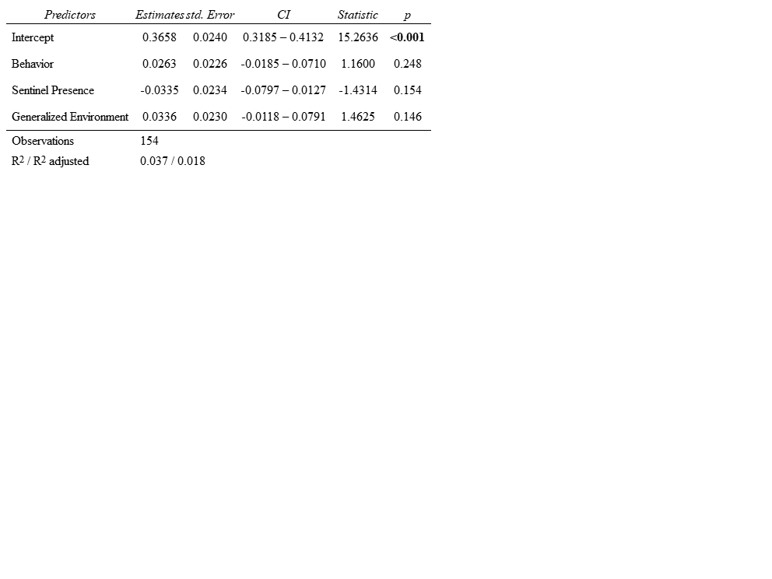

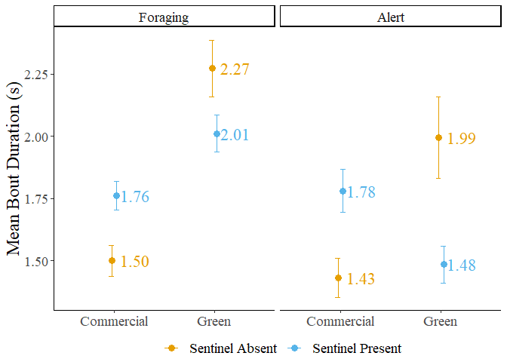

Figure 3: Mean bout duration of foragers in commercial and green areas. The error bars represent the standard error.

Table 2: Results of the linear mixed models fit to the mean bout duration

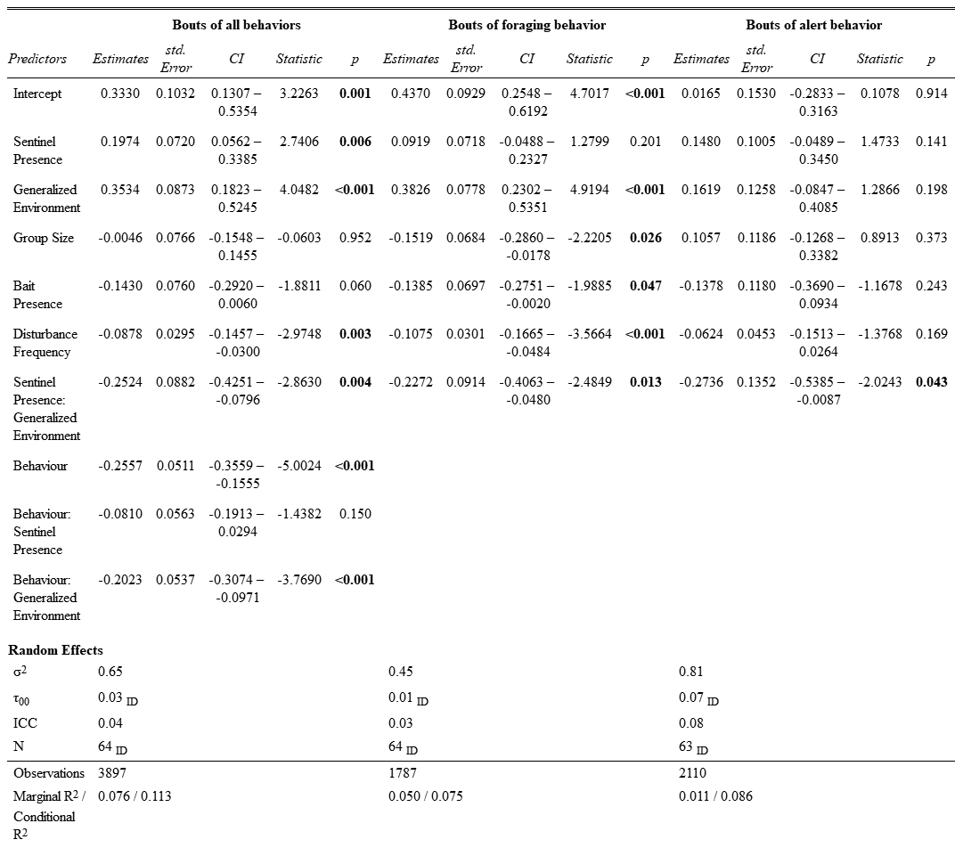

Duration of bouts of “foraging” behaviour

To determine if the generalized environment and sentinel presence affected the duration of bouts of foraging and alert behaviour differently, we fit separate linear mixed models for each type of behaviour bout. Sentinel presence had no significant effect on the duration of bouts of foraging behaviour ( $\hat{β}$ = 0.092, SE = 0.072, t = 1.280, p = 0.201; Figure 3, Table 2). Generalized environment had a significant effect on the duration of bouts of foraging behaviour, with longer bouts in green areas ( $\hat{β}$ = 0.383, SE = 0.078, t = 4.919, p = <0.001; Figure 3, Table 2). Larger groups had significantly longer bouts of foraging behaviour ( $\hat{β}$ = -0.152, SE = 0.068, t = -2.221, p = 0.026; Figure 4, Table 2). The presence of bait decreased the duration of foraging bouts ( $\hat{β}$ = -0.139, SE = 0.070, t = -1.989, p = 0.047; Figure S4, Table 2). Increasing disturbance frequency significantly decreased the duration of foraging bouts ( $\hat{β}$ = -0.108, SE = 0.030, t = -3.566, p = <0.001; Figure 5, Table 2). We found a significant interaction between generalized environment and sentinel presence ( $\hat{β}$ = -0.227, SE = 0.091, t = -2.485, p = 0.013; Figure 3, Table 2).

Post hoc tests revealed significant differences in the duration of bouts of foraging behaviour. In the absence of a sentinel, foragers in green areas had significantly longer bouts of foraging behaviour than in commercial areas ( $\hat{β}$ = -0.383, SE = 0.078, z-ratio = -4.919, p < 0.001; Table S3). In the presence of a sentinel, foragers in green areas also had significantly longer bouts of foraging behaviour than in commercial areas ( $\hat{β}$ = -0.156, SE = 0.067, z-ratio = -2.337, p = 0.029; Table S3). In green areas, foragers in the presence of a sentinel had marginally shorter bouts of foraging behaviour than in the absence of a sentinel ( $\hat{β}$ = 0.135, SE = 0.068, z-ratio = 1.977, p = 0.058; Table S3).

Duration of bouts of “alert” behaviour

Sentinel behaviour, generalized environment, group size, bait presence and disturbance frequency had no significant effect on the duration of bouts of alert behaviour (p < 0.141; Table 2). We found a significant interaction between sentinel behaviour and generalized environment ( $\hat{β}$ = -0.274, SE = 0.135, t = -2.024, p = 0.043; Figure 3, Table 2). Post hoc pairwise t-tests revealed no significant differences in the duration of bouts of alert behaviour.

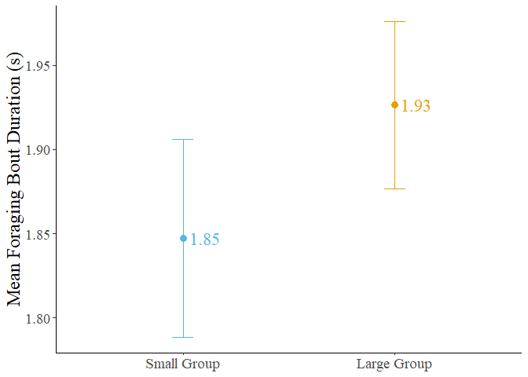

Figure 4: Mean foraging bout duration of crows in small and large groups. Error bars represent the standard error.

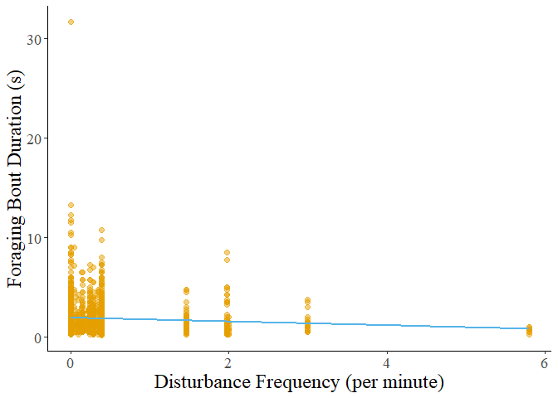

Figure 5: Foraging bout duration decreasing with increasing disturbance frequency.

Foraging rate

We calculated the peck rate (per min.) for 81 observations. Two observations were removed as the individuals did not perform any foraging behaviour. Neither the presence of a sentinel, the generalized environment, or group size had a significant effect on the peck rate of foragers (p > 0.233; Figure 6, Table 3). The presence of bait significantly increased the peck rate of foragers ( $\hat{β}$ = 13.990, t = 2.231, p = 0.020; Figure S5, Table 3). Peck rate increased significantly with disturbance frequency ( $\hat{β}$ = 5.290, t = 2.312, p = 0.021; Figure 7, Table 3). We found a significant interaction between generalized environment and disturbance frequency ( $\hat{β}$ = 16.150, t = 3.046, p = 0.002; Figure 7, Table 3).

Transition analysis

The number of transitions from foraging to alert behaviour was significantly higher in green areas (IRR = 0.421, SE = 0.157, z = -1.355, p = 0.020; Figure 8, Table 4), and in areas with frequent disturbances (IRR = 0.728, SE = 0.109, z = -2.130, p = 0.033; Figure 9, Table 4). We found a significant interaction between generalized environment and sentinel presence (IRR = 5.021, SE = 2.457, z = 3.298, p = 0.001; Figure 8, Table 4). The number of transitions from foraging to pecking was significantly higher in the presence of bait (IRR = 1.710, SE = 0.384, z = 2.386, p = 0.017; Figure S6, Table 4). All other factors did not affect the number of transitions from foraging to pecking (p-value > 0.385; Table 4). The number of transitions from pecking to alert behaviour was also significantly higher in the presence of bait (IRR = 2.204, SE = 0.538, z = 3.238, p = 0.001; Figure S6, Table 4). All other factors did not affect this transition (p-value > 0.235; Table 4). The number of transitions from alert to foraging behaviour were not significantly affected by any factors, however, bait presence had a marginally insignificant effect (IRR = 1.513, SE = 0.351, z = 1.789, p = 0.074; Figure S6, Table 4).

Post hoc testing on the number of transitions from foraging to alert behaviour revealed that in green areas, individuals performed more transitions from foraging to alert when in the presence of a sentinel ( $\hat{β}$ = -1.124, SE = 0.346, z-ratio = -3.250, p = 0.007; Table S4). Foragers in the presence of a sentinel performed marginally more transitions from foraging to alert in green areas than in commercial areas ( $\hat{β}$ = -0.749, SE = 0.364, z-ratio = -2.062, p = 0.079; Table S4). However, foragers in the absence of a sentinel performed marginally more transitions from foraging to alert behaviour in commercial areas than in green areas ( $\hat{β}$ = 0.864, SE = 0.372, z-ratio = 2.321, p = 0.061; Table S4).

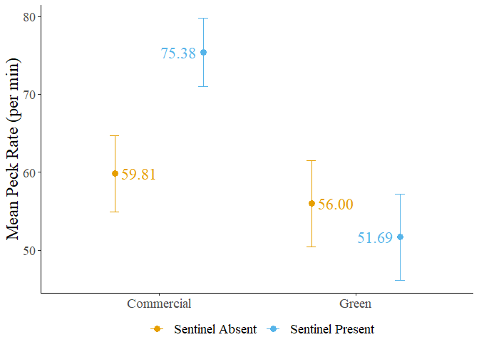

Figure 6: Mean peck rate of foragers in commercial and green areas. Error bars represent the standard error.

Table 3: Result of the linear mixed model fit to forager peck rate

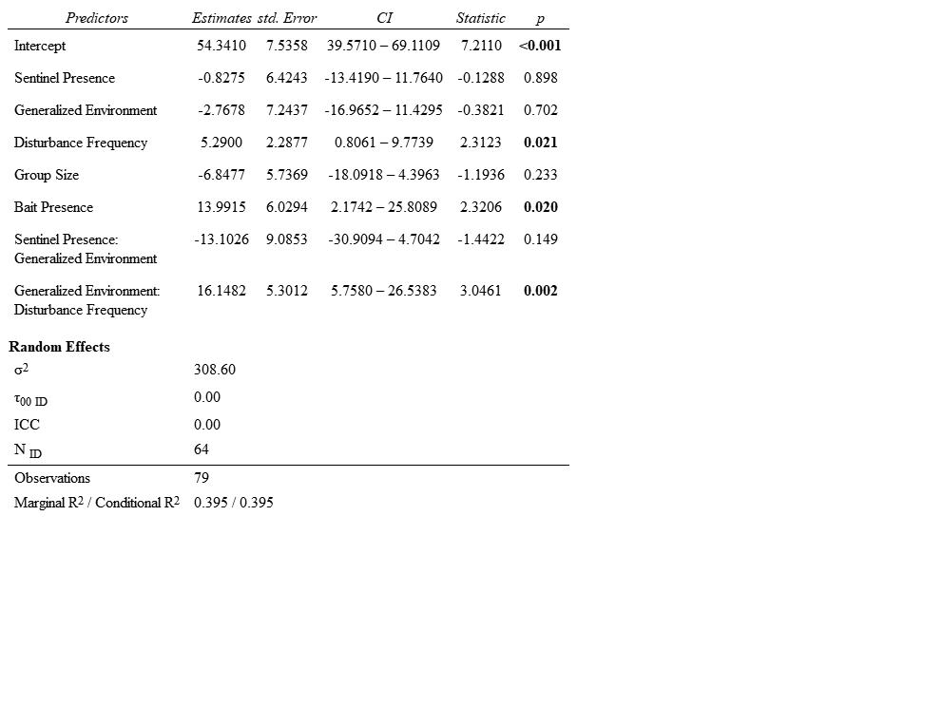

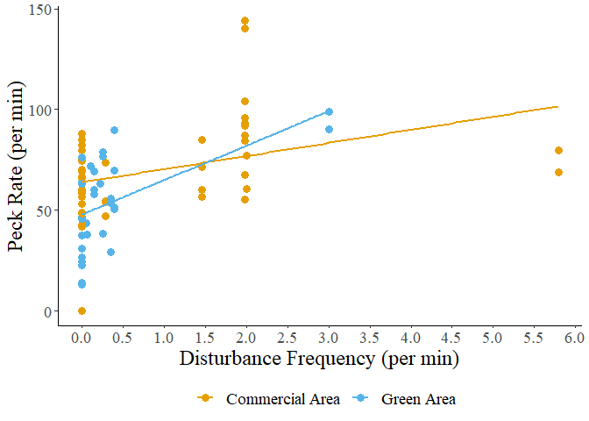

Figure 7: Peck rate of foragers in relation to disturbance frequency.

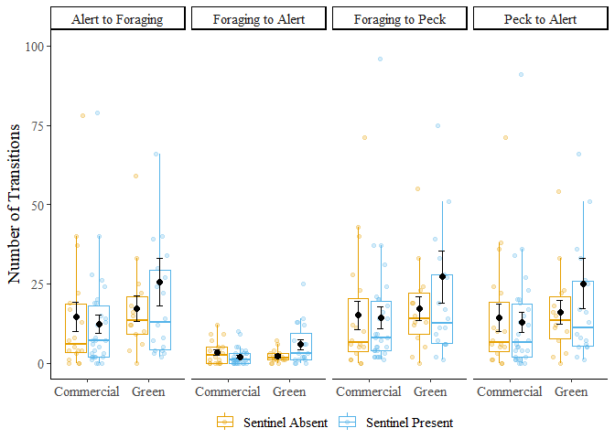

Figure 8: Number of transitions performed by foragers in commercial and green areas. Error bars represent the standard error. Three outliers (Nb.>100) omitted from figure.

Table 4: Results of generalized linear mixed model fit to the number of transitions performed by foragers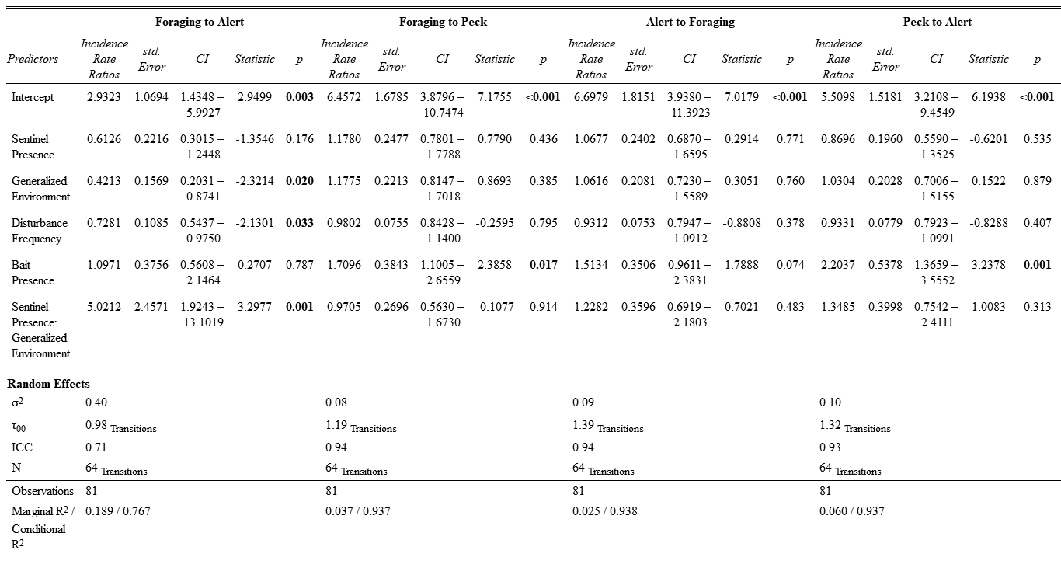

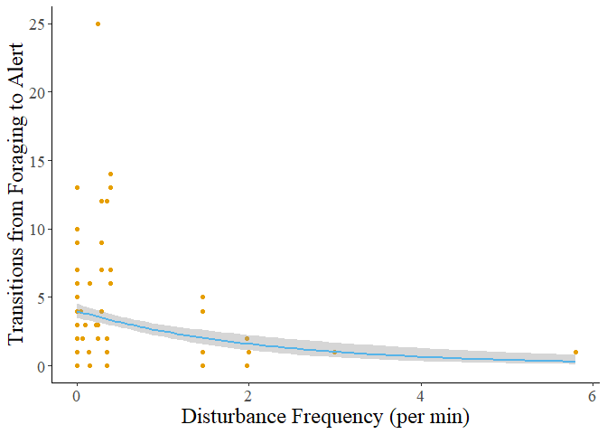

Figure 9: The number of transitions from foraging to alert behaviour decreases as disturbance frequency increases. The grey shadow represents the standard error of the curve.

Discussion

Our study sought to investigate how the presence of a sentinel and the foraging environment (generalized as either green areas or commercial areas) affected the behavior of foraging American crows. We initially hypothesized that the presence of a sentinel would decrease the individual vigilance of crow foragers, and that green areas would likewise decrease individual vigilance due to reduced ambient noise and longer lines of sight. We did not find any significant effects of sentinel presence on the behaviour of foragers apart from increasing the duration of all behaviours. Moreso, neither the generalized environment, disturbance frequency, nor group size significantly affected the presence of a sentinel in the videos. This unexpected result suggests that sentinel crows may decide to perform sentinel behavior based more on their energetic reserves rather than any environmental factors we tested. We found that the generalized environment had a significant effect on forager behavior, with green areas leading to longer bouts of foraging behavior and more transitions from the vulnerable to the alert state. This suggests that crows may perceive green areas as less safe, possibly because they need to spend more time being vulnerable. Overall, the study's findings do not fully support the initial hypotheses and suggest that sentinel behavior and forager behavior in crows could be influenced by complex interactions between individual factors and forager’s perception of the safety of their environment.

The lack of significant effects of sentinel behavior on forager behavior does not support the hypothesis that sentinel behaviour is an altruistic behaviour that provides benefits primarily to other group-members. Our findings that sentinel crows do not significantly influence the behavior of foragers contrasts with the results of previous studies that found that the presence of a sentinel led to a decrease in alert behavior and an increase in foraging efficiency for the group [7,8]. One possible explanation for this lack of effect could be that sentinel behavior is more selfish in nature, primarily benefiting the sentinel itself rather than the group. This would support Bedneckoff's state-dependent model, where individuals make decisions based on their own energetic needs and the benefits they receive [9]. If the alternative to being a sentinel is foraging without one, an individual with sufficient energetic reserves could decide to perform sentinel duties as a safer option. In urban areas, where high-calorie food patches are bountiful, individuals could be forgoing foraging to act as sentinels for their own safety. These sentinels only come down when they are below a critical energetic threshold past which performing sentinel behaviour is unfavourable. Another interpretation could be that the benefits of sentinel behavior are not easily discernible at the group level. This could suggest that the benefits of sentinel behavior are more subtle or indirect, such as providing a greater sense of security that allows foragers to focus more on foraging without actively reducing their vigilance.

Sentinel behaviour therefore may not always function as a cooperative strategy to benefit the group as a whole. Instead, it may be more self-serving; sentinels primarily benefiting from the increased vigilance and predator detection, and foragers receiving indirect benefits from the sentinel. The behavior of foraging group members could be more influenced by their own immediate needs and priorities rather than by the presence of a sentinel. This does not mean that forager will not utilize sentinel coverage, but some individual may use the benefits provided more than others, depending on how great the need to forage is. The relationship between sentinels and foragers could then be more complex than it appears, reinforcing the importance of considering individual differences and motivations when studying group behavior.

We found that the generalized environment had significant effects on forager behavior, particularly in terms of the duration of bouts of foraging behavior and the number of transitions from the vulnerable to the alert state. In green areas, crows exhibited longer bouts of foraging behavior, indicating that they spent more time actively searching for and consuming food. Likewise, there was an increase in the number of transitions from the vulnerable state to the alert state in green areas. This suggests that crows in green areas were more vigilant and alert to potential threats, possibly due to the perceived higher predation risk compared to commercial areas.

Green areas such as parks offer longer lines of sight and less ambient noise but could have a potentially higher predation risk compared to commercial areas. Though commercial areas have a greater frequency of disturbance, these disturbances could be from sources American crows are more tolerant to. One of the adaptations of urbanized species is an increased tolerance for anthropogenic disturbances, which could include pedestrians but also vehicles [10]. In contrast, there are fewer vehicles and pedestrians in green spaces but more pets and raptors which could trigger a greater reaction in foraging crows. The benefits provided by having longer lines of sight and decreased ambient noise could also be benefitting urban predators such as broad-winged hawks and red-tailed hawks which can often be seen perched nearby green spaces. Anecdotally, when raptors or unleashed dogs disturbed the foraging crows, they often flew away and abandoned the site, suggesting these disturbances are perceived as considerably more dangerous than vehicles or pedestrians.

The increased duration of foraging bouts in green areas could suggest that they need to spend more time actively searching for and consuming food. This could be due to vegetation or grassy areas obscuring food item, which may be more dispersed or require more time to locate. In contrast, commercial areas seemed to offer easier access to food via an increased presence of litter and scraps of highly caloric human foods. Such foods, especially when on concrete or other such impermeable surfaces, are easier to locate and quicker to consume than foods found in green spaces. This was observed in crows foraging in commercial areas which exhibited shorter bouts of foraging behavior but a higher peck rate than in green spaces. This could play a part in American crows shifting their foraging preferences for anthropogenic foods [11,12].

Our findings highlight how versatile the foraging strategies of American crows in urban areas can be. By altering their foraging behaviour based on the challenges and opportunities present in their foraging environment, American crows demonstrate a behavioural adaptability that is likely crucial for their success in a great diversity of habitats, including urban cityscapes. This is further demonstrated by the significant interaction we found between sentinel behavior and the generalized environment. This interaction suggests that the effects of sentinel behavior on forager behavior are not uniform across different environments.

In green areas, the number of transitions from a vulnerable to alert state exhibited by foraging crows is higher than in commercial areas, yet the number of transitions performed increases in green areas and in the presence of a sentinel is considerably higher than in the absence of a sentinel. The duration of bouts of alert behaviour are unchanged by the generalized environment, yet in the absence of a sentinel there is a substantial increase in the duration of bouts of alert behaviour in green areas. Conversely, when in the presence of a sentinel the duration of bouts of alert behaviour was shorter in green areas than in commercial areas. The magnitude of the increase in the duration of bouts of foraging behaviour in green areas was also greater in the absence of a sentinel compared to in the presence of a sentinel. This could be explained by forager use of the indirect benefits of sentinel presence, potentially allowing them to tolerate greater risks while maintaining sufficient anti-predator vigilance. In the absence of a sentinel, a crow may elect to abandon the foraging site if conditions are too risky, while crows in the presence of a sentinel could choose to remain and forage, all the while maintaining sufficient individual vigilance in addition to sentinel coverage. When conditions are tolerable, foraging crows could be choosing an all-or-nothing approach to foraging when in the absence of a sentinel, explaining the sharp increase in the duration of bouts of both alert and foraging behavior in green areas and in the absence of a sentinel.

In addition to sentinel presence and generalized environment, we also assessed the effects of three main environmental factors that could affect forager behaviour, namely disturbance frequency, bait presence, and group size. Higher disturbance frequency led to a decrease in the duration of bouts of all behaviors, particularly foraging. This suggests that crows adjust their behavior in response to disturbances, possibly to minimize their exposure to perceived threats. However, the peck rate increased with disturbance frequency, indicating that crows may increase their foraging efficiency when disturbances are more frequent. One important caveat to keep in mind is that our measurement of disturbance frequency does not consider the type of disturbances. Areas with higher disturbance frequencies typically had a greater frequency of vehicular disturbances, which American crows may be more tolerant. As a result and consistent with the risk allocation hypothesis, crows will continue to forage and may do so more intensely when doing so between cars. Higher disturbance frequency was also associated with a significant decrease in the number of transitions from foraging to alert behaviour, from which we can infer that crows will attempt to spend as little time as possible under threat while maximizing time spent foraging. Crows could then be foraging as quickly as possible and not taking the time to periodically look for threats (hence the decreased number of transitions), instead taking to the skies as soon as a threat is detected.

The presence of bait, which can be considered a proxy for human-generated litter in the environment, increased the peck rate and decreased the duration of foraging bouts. This suggests that foraging on bait or litter is more efficient and safer for crows, as it requires less time and effort compared to foraging on natural food sources. This observation could explain why a shift in preference for anthropogenic foods is observed in American crows and potentially other urbanized species [11,12].

As group size increased, the duration of bouts of foraging behaviour increased but was not associated with a decrease in duration of bouts of alert behaviour. The proportion of time allocated to either behaviour was also unchanged by the size of the group. This finding is surprising, as previous studies suggest that larger group sizes should decrease individual vigilance while increasing foraging efficiency [13–15], yet the effect of group size was only observed in the duration of bouts of foraging behaviour. Bouts of alert behaviour may have a minimal duration to effectively monitor the surrounding environment for sources of threat. Alternatively, foraging crows may be maintaining vigilance due to increased competition for resources in larger groups. Instead of only looking out for sources of threat, forager could instead be looking at the behaviour of other group-members in case they found a better patch to forage on.

Our study has several limitations that should be acknowledged. Our sample size may have limited the ability to detect significant effects. While efforts were made to collect a sufficient number of observations, we were limited by the crow’s decision to forage around the researchers. As such, caution should be exercised when interpreting the results, and further studies with larger sample sizes are required to make conclusive statements. Additionally, the study focused on the population of crows in inhabiting St. Catharines, which may limit the generalizability of our results to other populations or environments. Factors such as local food availability and predator presence can vary widely between cities, and these factors may influence the behaviors observed in this study. Therefore, the findings of our study could differ from those of a similar study performed on a different population and in a different city. Our study also lacks a control group from a non-urban foraging site, the inclusion of which could demonstrate how urbanization as a whole can affect the social behaviour of crows. Although different urban areas were sampled in, the fact remains that only urban populations were observed, and less urbanized populations could behave in a different manner.

Furthermore, certain results from the study were difficult to interpret, particularly regarding the interaction between sentinel behavior and the generalized environment. The reasons behind these interactions are complex and may involve a combination of ecological, social, and individual factors that were not fully explored in this study. Future research should aim to further investigate these interactions to gain a better understanding of the underlying mechanisms.

Lastly, it is impossible to truly separate the effects of different factors from one-another. For example, the effects of generalized environment and disturbance frequency could be interrelated, as commercial areas will generally have increased disturbance frequency as a result of vehicular traffic, while green areas may have fewer disturbances but of a type that crows are less tolerant or intolerant to.

While our study provides valuable insights into the behaviors of crows in different environments, its limitations should be considered when interpreting the results, and further research is needed to fully elucidate social behaviour of urban crows. For example, future research could look at the levels and patterns of aggression in urbanized crows. This could provide further insights into how urban environments influence social behavior and could involve observing interactions between crows in different urban settings and comparing them to interactions in less urbanized areas.

Our study investigated the effects of sentinel behavior and the generalized environment on the behavior of foraging crows in urban environments. Contrary to expectations, sentinel behavior did not have a significant effect on forager behavior. This suggests that sentinel decision-making may be more influenced by individual needs rather than group benefits, aligning with Bednekoff's state-dependent model. The generalized environment had a significant impact on forager behavior. Crows in green areas exhibited longer bouts of foraging behavior and more transitions from the vulnerable to the alert state compared to those in commercial areas. This indicates that environmental factors such as resource distribution and predation risk play a crucial role in shaping forager behavior. Disturbance frequency, bait presence, and group size also influenced forager behavior. Higher disturbance frequency led to shorter bouts of behavior but increased peck rate, indicating a trade-off between vigilance and foraging efficiency. Bait presence increased peck rate and decreased foraging time, suggesting that foraging on anthropogenic food sources may be more effective for crows.

These findings have several implications for understanding crow behavior. They suggest that crows are able to adapt their behavior based on environmental conditions and individual needs. The lack of significant effects of sentinel behavior points towards the complexity of social behavior in crows and the importance of considering individual variation in decision-making. Overall, the study provides valuable insights into the factors influencing crow behavior in urban environments and highlights the need for further research to fully understand these complex behaviors.

References

1. Møller AP. 1990 Changes in the size of avian breeding territories in relation to the nesting cycle. *Anim. Behav.* **40**, 1070–1079. (doi:10.1016/S0003-3472(05)80173-3)

2. Friard O, Gamba M. 2016 BORIS: a free, versatile open-source event-logging software for video/audio coding and live observations. *Methods Ecol. Evol.* **7**, 1325–1330. (doi:10.1111/2041-210X.12584)

3. R Core Team. 2022 R: the R project for statistical computing.

4. Koller M. 2016 Robustlmm: an R package for robust estimation of linear mixed-effects models. *J. Stat. Softw.* **75**, 1–24. (doi:10.18637/jss.v075.i06)

5. Bates D, Mächler M, Bolker B, Walker S. 2015 Fitting linear mixed-effects models using lme4. *J. Stat. Softw.* **67**, 1–48. (doi:10.18637/jss.v067.i01)

6. Lenth RW. 2023 Emmeans: estimated marginal means, aka least-squares means.

7. Hollén LI, Bell MBV, Radford AN. 2008 Cooperative sentinel calling? Foragers gain increased biomass intake. *Curr. Biol.* **18**, 576–579. (doi:10.1016/j.cub.2008.02.078)

8. Ridley AR, Wiley EM, Thompson AM. 2014 The ecological benefits of interceptive eavesdropping. *Funct. Ecol.* **28**, 197–205. (doi:10.1111/1365-2435.12153)

9. Bednekoff PA. 1997 Mutualism among safe, selfish sentinels: a dynamic game. *Am. Nat.* **150**, 373–392. (doi:10.1086/286070)

10. Isaksson C. 2018 Impact of urbanization on birds. In *Bird Species: How They Arise, Modify and Vanish* (ed DT Tietze), pp. 235–257. Cham: Springer International Publishing. (doi:10.1007/978-3-319-91689-7_13)

11. Marzluff JM, Neatherlin E. 2006 Corvid response to human settlements and campgrounds: Causes, consequences, and challenges for conservation. *Biol. Conserv.* **130**, 301–314. (doi:10.1016/j.biocon.2005.12.026)

12. Marzluff JM, McGowan KJ, Donnelly R, Knight RL. 2001 Causes and consequences of expanding American Crow populations. In *Avian Ecology and Conservation in an Urbanizing World* (eds JM Marzluff, R Bowman, R Donnelly), pp. 331–363. Boston, MA: Springer US. (doi:10.1007/978-1-4615-1531-9_16)

13. Beauchamp G. 2013 *Social predation: how group living benefits predators and prey*. Elsevier.

14. Beauchamp G. 2008 What is the magnitude of the group-size effect on vigilance? *Behav. Ecol.* **19**, 1361–1368. (doi:10.1093/beheco/arn096)

15. Lima SL. 1995 Back to the basics of anti-predatory vigilance: the group-size effect. *Anim. Behav.* **49**, 11–20. (doi:10.1016/0003-3472(95)80149-9)

Supplemental Material

List of Supplemental Tables

Table S1: Explanation of generalized environment 22

Table S2: Ethogram of behaviours analyzed during foraging events 23

Table S3: Results of post hoc tests on foraging bout duration 27

Table S4: Result of post hoc test performed on the number of transitions from foraging to alert behaviour 31

List of Supplemental Figures

Figure S1: Sentinel presence in commercial and green areas 24

Figure S2: Frequency plots of observations in the presence and absence of a sentinel 25

Figure S3: Decreasing bout duration of all behaviours in response to increasing disturbance frequency 26

Figure S4: Mean bout duration in the presence and absence of bait 28

Figure S5: Mean forager peck rate in the presence and absence of bait 29

Figure S6: Number of transitions performed by foragers in the presence and absence of bait 30

Table S1: Explanation of generalized environment.

|  |  |
| --- | --- |
| Generalized Environment | Zones included |
| Commercial Area | Arterial Commercial, Business Commercial Employment, Community Commercial, Major Commercial |
| Green Area | Major Green Space, Minor Green Space |

Each zone type was identified using the St. Catharines and Niagara zoning maps for each sampling location.

Table S2: Ethogram of behaviours analyzed during foraging events.

|  |  |  |  |
| --- | --- | --- | --- |
| Behaviour | Code | Definition | Illustration |
| Foraging | Head Down | Focal individual is stationary and has its head downwards or in a non-upright position, either pecking or handling food, looking for food, or engaging in other behaviours that make vigilance ineffective (e.g. preening). |  |
| Moving | Moving | Focal individual is moving, either by flying, hopping (leaping), or walking. |  |
| Alert | Head Up | The focal individual is stationary and has its head and body in an upright position. Individuals can have a mobile (scanning) or immobile head but must not be looking downwards. Individuals can be handling food. |  |

*All illustrations are under creative commons license (copyright-free)*

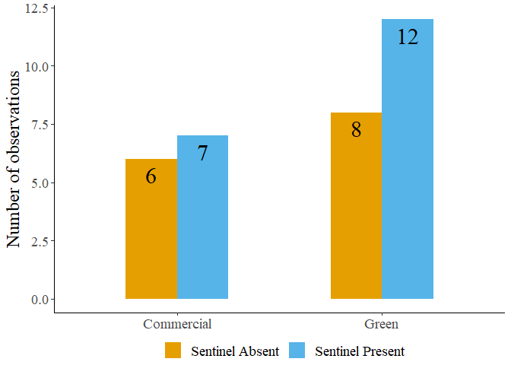

Figure S1: Sentinel presence in commercial and green areas.

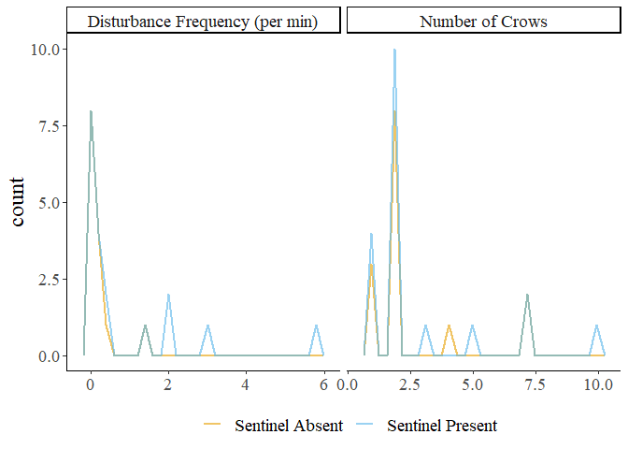

Figure S2: Frequency plots of observations in the presence and absence of a sentinel.

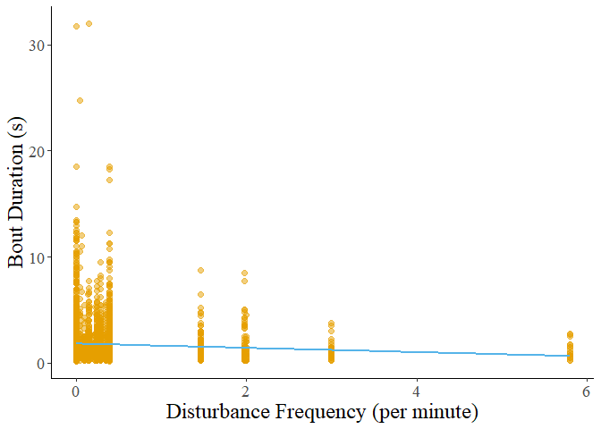

Figure S3: Decreasing bout duration of all behaviours in response to increasing disturbance frequency.

Table S3: Results of post hoc tests on foraging bout duration.

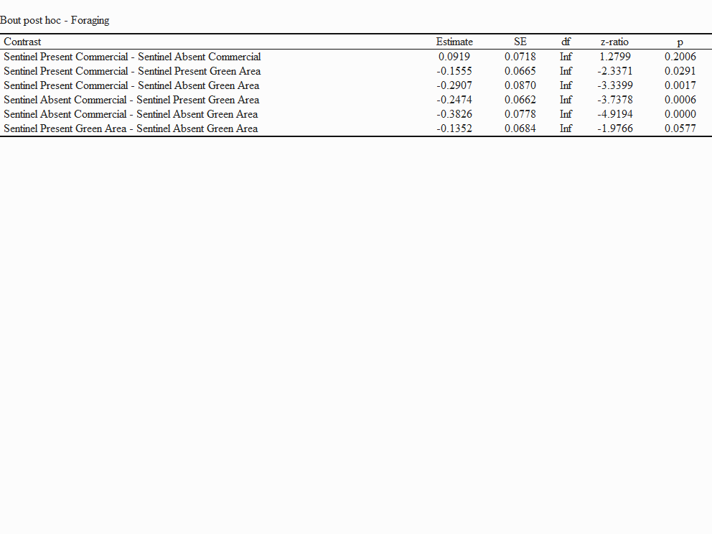

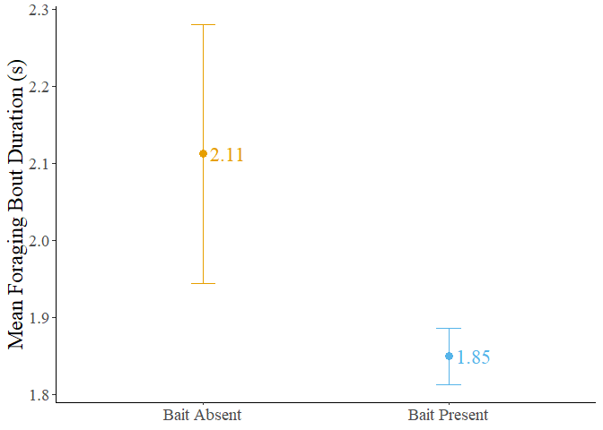

Figure S4: Mean bout duration in the presence and absence of bait. The dots represent the mean value, and the error bars represent the standard error.

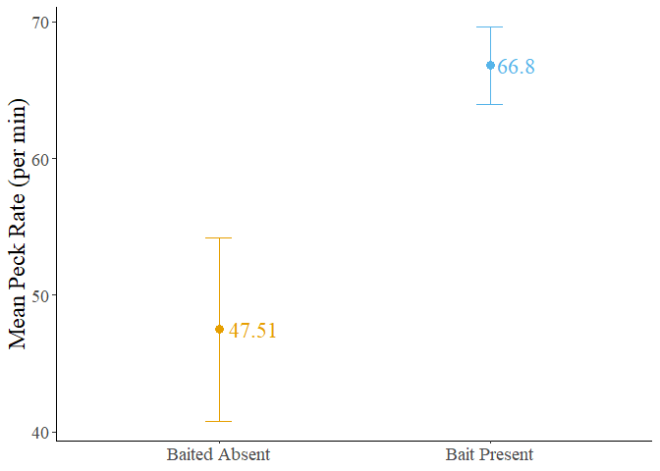

Figure S5: Mean forager peck rate in the presence and absence of bait. The dots represent the mean value, and the error bars represent the standard error.

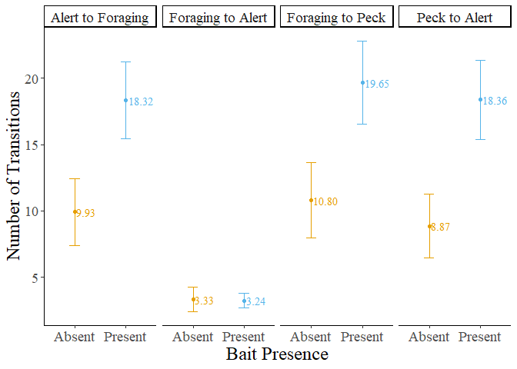

Figure S6: Number of transitions performed by foragers in the presence and absence of bait. The dots represent the mean value, and the error bars represent the standard error.

Table S4: Result of post hoc test performed on the number of transitions from foraging to alert behaviour.

